TABLE OF CONTENTS
1 Practice 1: Create iOS Project by using Master-Detail Template 4
1.1 Create new Master-Detail template Project 4
1.1.1 File -> New -> Project… 4
1.1.2 Choose Master-Detail template and click “Next” button 4
1.1.3 Naming the project is “Incident Tracking” and click “Next” button. 5
1.1.4 The project structure 5
2 Practice 2: Create Custom cell and Populating Table View with Data 6
2.1 Create Model (Incident object and DataManager object): 6
2.1.1 Right Click on Incident Tracking Folder - > New File 6
2.1.2 Naming and Choosing supper class and click “Next” button 6
2.1.3 Click Create to save the files to Incident Tracking folder 7
2.1.4 Adding properties for Incident object in Incident.h 7
2.1.5 Create DataManager Object with the contents as below 8
2.2 Create Custom TableViewCell 9
2.2.1 Select Folder on the Incident Tracking Folder –> New File 9
2.2.2 Naming and Choosing supper class and click “Next” button. 9
2.2.3 Click Create to save the files to Incident Tracking folder 9
2.2.4 Select Folder on the Incident Tracking Folder –> New File 9
2.2.5 Choose View Template 9
2.2.6 Naming IncidentViewCell and click “Next” button. 9
2.2.7 Drag and Drop Table View Cell to editor screen. 10
2.2.8 Referencing Outlets 10
2.2.9 Naming the property and click Connect button. 11
2.2.10 Repeat with others control. 11
2.3 Populating MasterViewController with Data. 11
2.4 Run the application with Simulator 12
2.5 Detail Screen: 13
2.5.1 Select DetailViewController.xib and adding the controls as screen below 13
2.5.2 Referencing Outlet: (Please refer step 2.2.8 and 2.2.9) 13
2.5.3 Populating DetailViewController with Data 14
3 Pratice 3: Create Adding Incident Screen and Using NavigationController to show the screen. 15
3.1 Create AddIncident Screen 15
3.1.1 Create AddIncidentViewController 15
3.1.2 Drag and Drop the controls as below and Create Referencing Outlets. (refer to step 2.2.8, 2.2.9) 15
3.1.3 Editing DetailViewController.m as below 16
3.1.4 Editing AddIncidentViewController.m 16
3.1.5 Editing MasterViewController.m 17

Assignment: Implement Incident Tracking Application – iPad Application
Features:
- List incident
- View incident detail
- Add new incident
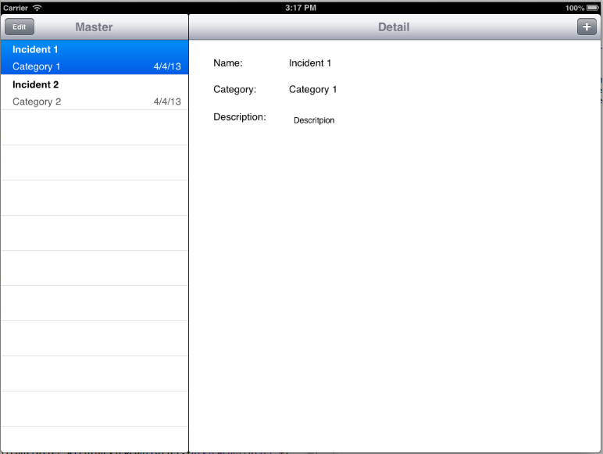
List incident
Incident detail

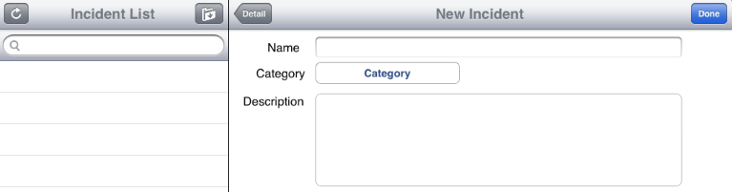
Add new incident

Practice 1: Create iOS Project by using Master-Detail Template

Create new Master-Detail template Project

File -> New -> Project…
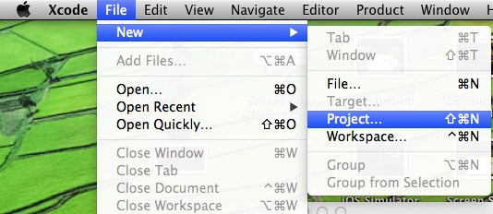

Choose Master-Detail template and click “Next” button
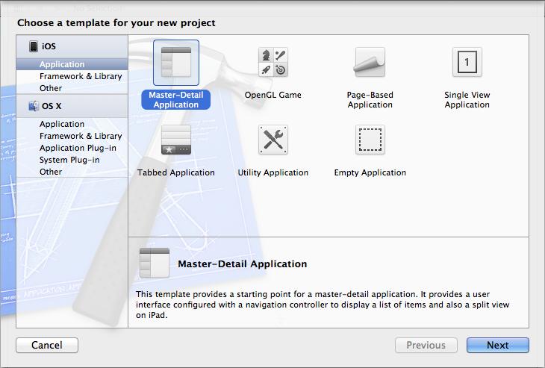

Naming the project is “Incident Tracking” and click “Next” button.
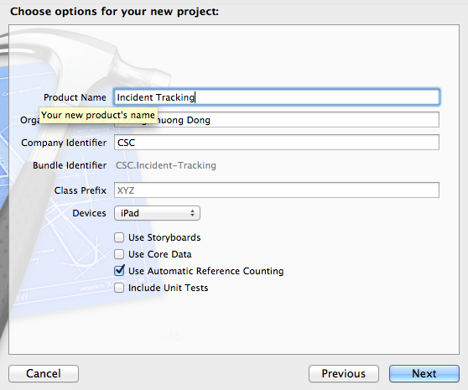

The project structure
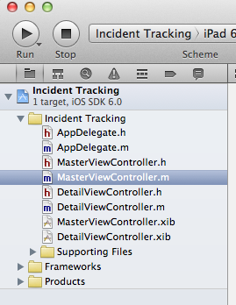

Practice 2: Create Custom cell and Populating Table View with Data

Create Model (Incident object and DataManager object):

Right Click on Incident Tracking Folder - > New File
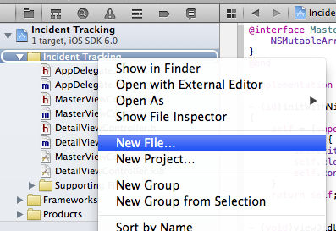

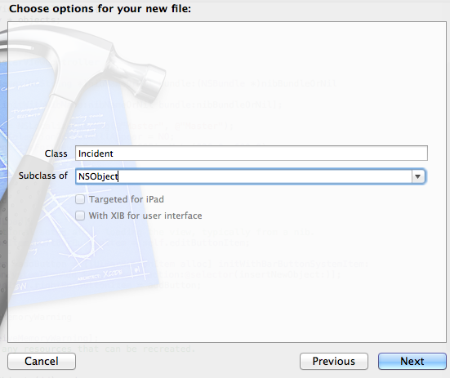
Naming and Choosing supper class and click “Next” button

Click Create to save the files to Incident Tracking folder
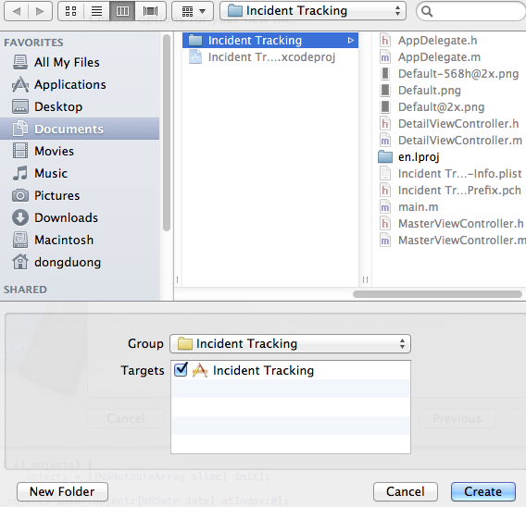

Adding properties for Incident object in Incident.h
@property (nonatomic, retain) NSString *name;
@property (nonatomic, retain) NSString *category;
@property (nonatomic, retain) NSString *description;
@property (nonatomic, retain) NSDate *createDate;
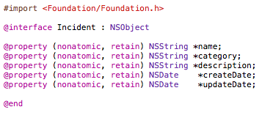
@property (nonatomic, retain) NSDate *updateDate;

Create DataManager Object with the contents as below

DataManager.h
#import <Foundation/Foundation.h>

@interface DataManager : NSObject

@property (nonatomic, retain) NSMutableArray *incidentList;

+ (DataManager *)sharedInstance;

@end

DataManager.m

#import "DataManager.h"
#import "Incident.h"

static DataManager *dmInstance = nil;

@implementation DataManager

+ (DataManager *)sharedInstance {
@synchronized (self) {
if (dmInstance == nil) {
dmInstance = [[self alloc] init];
}
}
return dmInstance;
}

- (id) init {
self = [super init];
if (self) {

_incidentList = [[NSMutableArray alloc] init];

Incident *inc = [[Incident alloc] init];
inc.name = @"Incident 1";
inc.category = @"Category 1";
inc.description = @"Descritpion 1";
inc.createDate = [NSDate date];

[_incidentList addObject:inc];

inc = [[Incident alloc] init];

inc.name = @"Incident 2";
inc.category = @"Category 2";
inc.description = @"Descritpion 2";
inc.createDate = [NSDate date];

[_incidentList addObject:inc];
}
return self;
}
@end

Create Custom TableViewCell

Select Folder on the Incident Tracking Folder –> New File

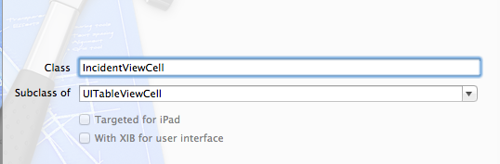
Naming and Choosing supper class and click “Next” button.

Click Create to save the files to Incident Tracking folder

Select Folder on the Incident Tracking Folder –> New File

Choose View Template
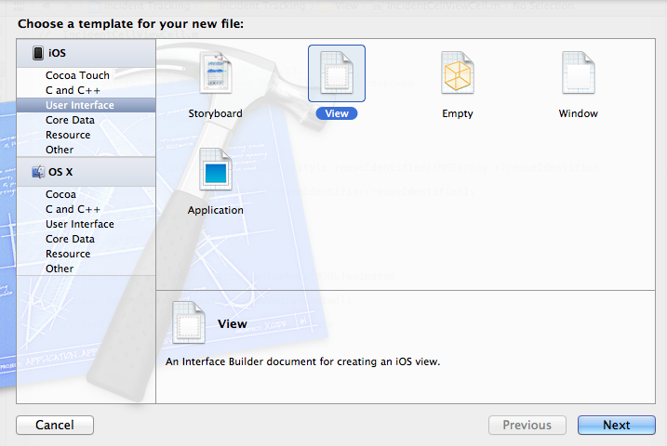

Naming IncidentViewCell and click “Next” button.

Drag and Drop Table View Cell to editor screen.
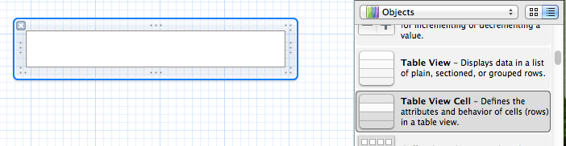

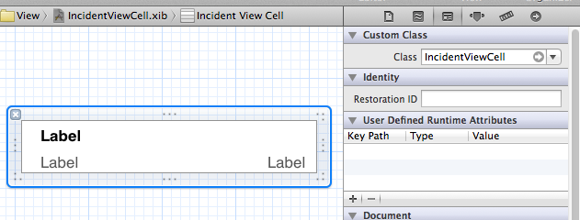
  - Drag and Drop UILabel to Table View Cell -> Change the Class to IncidentViewCell

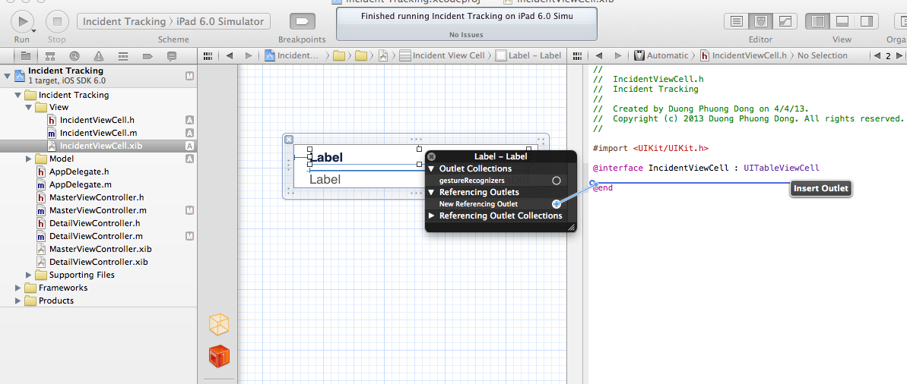
Referencing Outlets
2.Select editor
3.Right Click
4.Drag and Drop
1.Select xib file

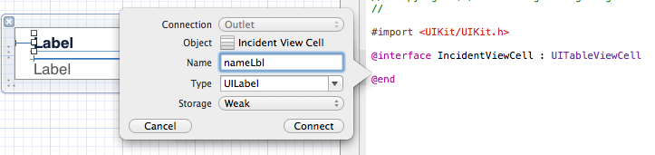
Naming the property and click Connect button.

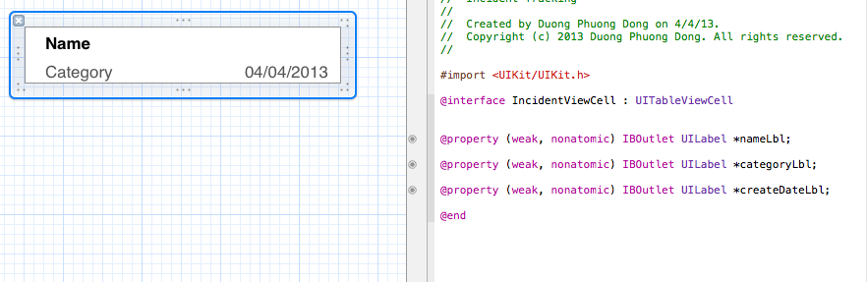
Repeat with others control.

Populating MasterViewController with Data.
Importing Incident.h, IncidentViewCell.h and DataManager.h to MasterViewController.m
Editing 3 methods in MasterViewController.m as below:
- (NSInteger)numberOfSectionsInTableView:(UITableView *)tableView
{
return 1;
}

- (NSInteger)tableView:(UITableView *)tableView numberOfRowsInSection:(NSInteger)section
{
return [[DataManager sharedInstance].incidentList count];
}

// Customize the appearance of table view cells.
- (UITableViewCell *)tableView:(UITableView *)tableView cellForRowAtIndexPath:(NSIndexPath *)indexPath
{
static NSString *CellIdentifier = @"Cell";

IncidentViewCell *cell = [tableView dequeueReusableCellWithIdentifier:CellIdentifier];
if (cell == nil) {
//cell = [[IncidentCell alloc] initWithStyle:UITableViewCellStyleDefault reuseIdentifier:CellIdentifier];
NSArray* views = [[NSBundle mainBundle] loadNibNamed:@"IncidentViewCell" owner:nil options:nil];

for (UIView *view in views) {
if([view isKindOfClass:[UITableViewCell class]])
{
cell = (IncidentViewCell*)view;
}
}
}

Incident *inc = [[DataManager sharedInstance].incidentList objectAtIndex:indexPath.row];
cell.nameLbl.text = inc.name;
cell.categoryLbl.text = inc.category;

NSString *dateString = [NSDateFormatter localizedStringFromDate:inc.createDate
dateStyle:NSDateFormatterShortStyle
timeStyle:NSDateFormatterNoStyle];

cell.createDateLbl.text = dateString;
return cell;
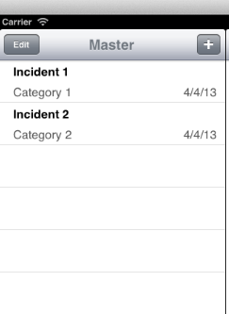
}

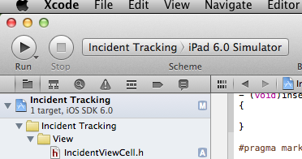
Run the application with Simulator

Detail Screen:

Select DetailViewController.xib and adding the controls as screen below
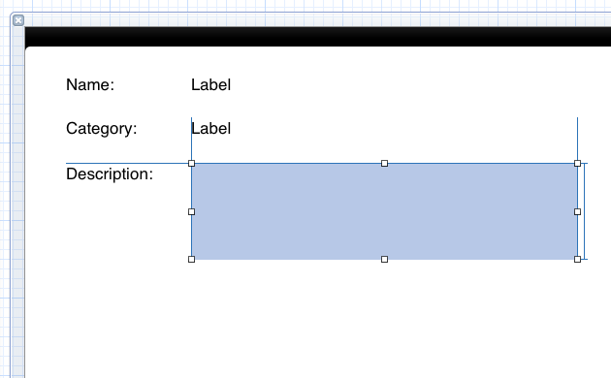

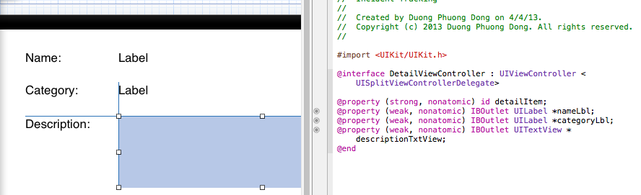
Referencing Outlet: (Please refer step 2.2.8 and 2.2.9)

Populating DetailViewController with Data
Editing the method in DetailViewController.m as below:
- (void)setDetailItem:(Incident*)newDetailItem
{
if (_detailItem != newDetailItem) {
_detailItem = newDetailItem;

// Update the view.
[self configureView];
}

if (self.masterPopoverController != nil) {
[self.masterPopoverController dismissPopoverAnimated:YES];
}
}

- (void)configureView
{
// Update the user interface for the detail item.

if (self.detailItem) {
self.nameLbl.text = [self.detailItem name];
self.categoryLbl.text = self.detailItem.category;
self.descriptionTxtView.text = [self.detailItem description];
}
}
Editing the method in MaterViewController.m as below:

- (void)tableView:(UITableView *)tableView didSelectRowAtIndexPath:(NSIndexPath *)indexPath
{
Incident *object = [[DataManager sharedInstance].incidentList objectAtIndex:indexPath.row];
self.detailViewController.detailItem = object;
}

Pratice 3: Create Adding Incident Screen and Using NavigationController to show the screen.

Create AddIncident Screen

Create AddIncidentViewController
Right Click on Incident Tracking folder –> New File
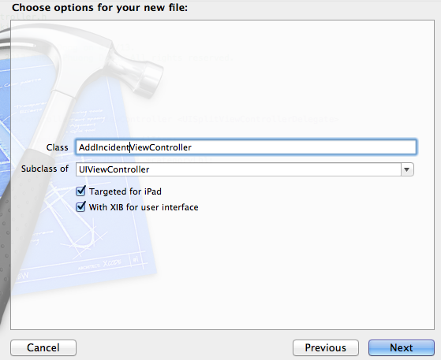

Drag and Drop the controls as below and Create Referencing Outlets. (refer to step 2.2.8, 2.2.9)
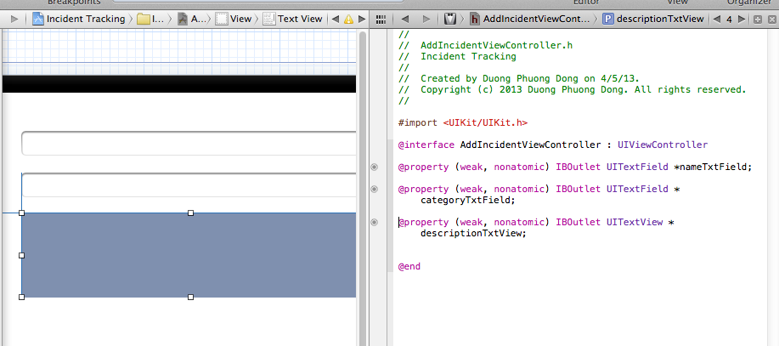

Editing DetailViewController.m as below
- (void)viewDidLoad
{
[super viewDidLoad];
// Do any additional setup after loading the view, typically from a nib.
UIBarButtonItem *addButton = [[UIBarButtonItem alloc] initWithBarButtonSystemItem:UIBarButtonSystemItemAdd target:self action:@selector(addNewIncident)];
self.navigationItem.rightBarButtonItem = addButton;
[self configureView];
}

- (void)addNewIncident {
AddIncidentViewController *addVC = [[AddIncidentViewController alloc] initWithNibName:@"AddIncidentViewController" bundle:nil];

[self.navigationController pushViewController:addVC animated:TRUE];
}

Editing AddIncidentViewController.m
- (void)viewDidLoad
{
[super viewDidLoad];
// Do any additional setup after loading the view from its nib.
self.navigationItem.title = @"New Incident";

UIBarButtonItem *doneButton = [[UIBarButtonItem alloc] initWithBarButtonSystemItem:UIBarButtonSystemItemDone target:self action:@selector(doneBtnTouched)];
self.navigationItem.rightBarButtonItem = doneButton;

}

- (void) doneBtnTouched {

Incident *inc = [[Incident alloc] init];
inc.name = self.nameTxtField.text;
inc.category = self.categoryTxtField.text;
inc.description = self.description;
inc.createDate = [NSDate date];

[[DataManager sharsedInstance].incidentList addObject:inc];

[[NSNotificationCenter defaultCenter] postNotificationName:@"updatedIncidentList" object:nil];

[self.navigationController popViewControllerAnimated:true];
}

Editing MasterViewController.m
Adding the code below to viewDidLoad
[[NSNotificationCenter defaultCenter] addObserver:self
selector:@selector(updatedIncidentList)
name:@"updatedIncidentList"
object:nil];

Adding the method below
- (void)updatedIncidentList {
[self.tableView reloadData];
}

